**Server problems**

If we get a problem and get complains about server slow, we restarted the server using a commands in the terminal. We have several servers we control but some not.

they all have their name we find it in the link <https://docs.google.com/spreadsheets/d/1EkyWvzz6I2oEXn3WBBTWUP7a4OnFFjTVs2I-nbO6XIg/edit#gid=0> . the name will be changed in number 2 in the sequence below. Example qaapp1

1. Before you go to the terminal make sure you send email to all q-interactive team saying that you are restarting by saying like:- Because QA is running exceptionally slowly, it will be restarted
2. Type qaapp1
3. you will be asked the passwords which is at the link <https://docs.google.com/spreadsheets/d/1EkyWvzz6I2oEXn3WBBTWUP7a4OnFFjTVs2I-nbO6XIg/edit#gid=0>
4. then you type cd qiactive/tomcat
5. then you type bin/shutdown.sh
   1. sometimes it might have already been shut down so just start it again
6. you clean up then by typing cleanme
7. you restart it then bin/startup.sh
8. you can log into the server to see how they are doing using go to cd logs
9. then check what is going on using the command tail -f catalina.out
10. to kill it by force first find the PID using ps aux | grep java
11. then do this to kill it kill -9 PID
12. To check if tomcat is running use this command ps -aef | grep java
13. to get the top server details at the terminal is top -hv | -abcHimMsS -d delay -n iterations -p pid [, pid ...] and description is listed in the link <http://blog.scoutapp.com/articles/2014/07/31/slow_server_flow_chart>
14. you can also use this free -m command instead of the top command
15. To check which port is being used or if the specific port number is being used you type in the terminal: for example for 8080 port number: netstat -tulpno | grep :8080
16. I can restart Jenkins using the command using service Jenkins restart

There are times we get a environment server problem we cannot fixes but we can request by getting tickets in the link <https://pearsonstsprod.service-now.com/main/newchange.do>

That way we can make all the request and send it. After we send also we need to hit another button to make it actual send and request. Like for BETA and TEST. In the example below it is for TEST

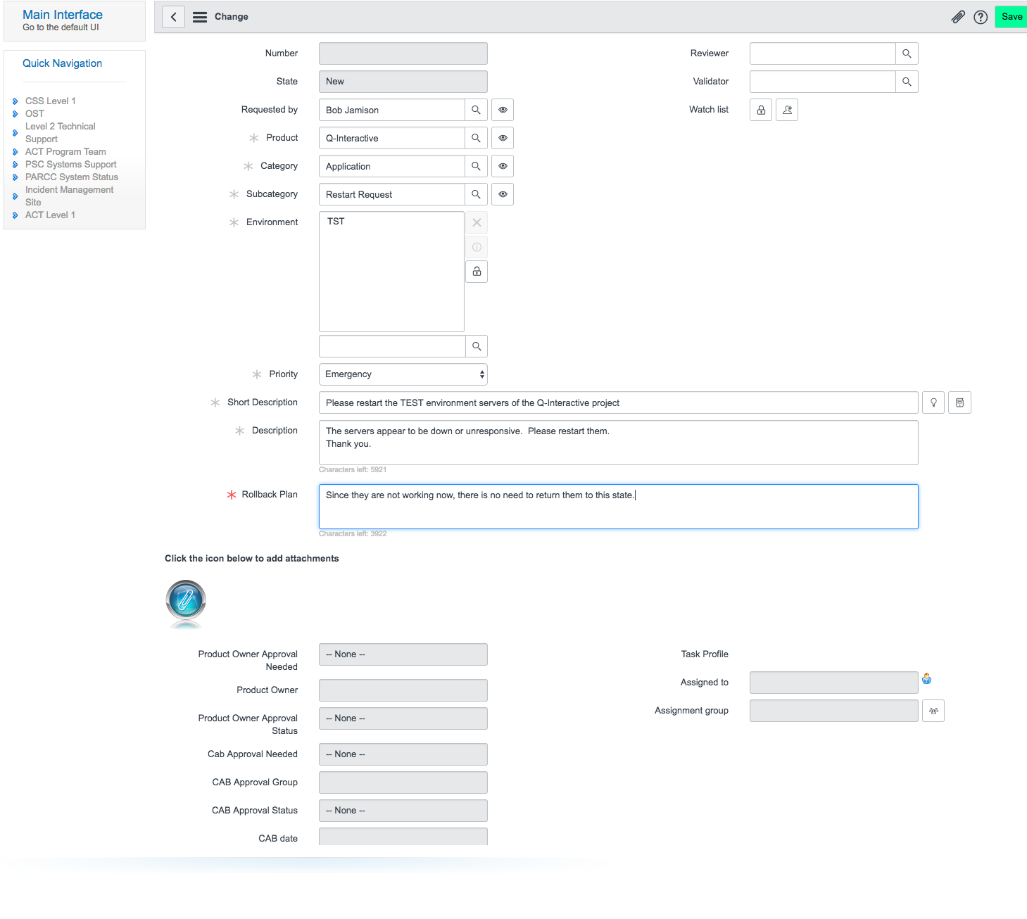

there are times we get a problem when a remote server is restarted, we do not get another documentation and request do not work. To fix that we can follow some given or company provided documentation and fix it.

1. Example if the build box is restarted and we face a problem to start the documentation for firefighter, we get the documentation provided by the company at the link <https://github.com/pearca/developer/blob/master/content/fires/mac-build-box.md>
2. Following the documentation especially the last two script under the restarting sub topic, we can restart the website. But sometimes it does not work you will get a problem. Sometimes you get the problem with npm and install that. But mostly you should be able to see the logs and get the message what is going on and you will be able to get the error message. Like you can check using the command vim ~/startDocumentation.sh and see what is inside it. And you will find a file which contains the error message inside that file. And you can log to it as well using cat or vim. Like vim documentation_error.log. then you can act you correction based your error messages.